LOCAL PUBLIC TRANSPORTATION SURVEY

**A PROJECT REPORT**

SUBMITTED IN PARTIAL FULFILLMENT OF THE REQUIREMENTS FOR THE AWARD OF THE DEGREE OF

**BACHELOR OF SCIENCE (DATA SCIENCE)**

BY

**KADAM DISHA SUDHIR TANVI**

**2417622**

UNDER THE GUIDANCE OF

**DR. HIREN DAND**

HEAD, DEPARTMENT OF INFORMATION TECHNOLOGY

**DEPARTMENT OF DATA SCIENCE**

**PARLE TILAK VIDYALAYA ASSOCIATION’S**

**MULUND COLLEGE OF COMMERCE (AUTONOMOUS)**

***(AFFILIATED TO UNIVERSITY OF MUMBAI)***

***NAAC RE-ACCREDITED A GRADE – 3 CYCLES***

**MULUND WEST, MUMBAI 400080**

**MAHARASHTRA, INDIA**

**2024-25**



Parle Tilak Vidyalaya Association’s

MULUND COLLEGE OF COMMERCE (AUTONOMOUS)

***(Affiliated to University of Mumbai)***

***NAAC Re-Accredited A Grade – III Cycle***

**MULUND WEST, MUMBAI 400080**

**MAHARASHTRA, INDIA**

SCHOOL OF COMPUTING AND TECHNOLOGY

CERTIFICATE

This is to certify that the project entitled, **"Local Public Transportation Survey"**, is bonafide work of **Disha Sudhir Kadam** bearing Seat. No: 2417622 submitted in partial fulfilment of the requirements for the **Third year** of **BACHELOR OF SCIENCE in DATA SCIENCE Semester V** during the academic year 2024 – 2025.

Internal Guide and Coordinator Principal

College seal

External Examiner College Seal

**PROJECT APPROVAL**

|  |  |  |  |
| --- | --- | --- | --- |
|  | PRN No | : |  |
|  | Roll No | : | **2417622** |
|  | Name of the Student | : | **Kadam Disha Sudhir Tanvi** |
|  | Title of the Project | : | **Local Public Transportation Survey** |
|  | Name of the Guide | : | **Dr. Hiren Dand** |
|  | Teaching Experience of Guide | : | **33 years** |
|  | Is this your first Submission | : | **Yes** |

**Acknowledgment**

I have a great pleasure in representing this project report entitled “Local Public Transportation Survey.” And I grab this opportunity to convey my immense regards towards all the distinguished people who have their valuable contribution in the Hour of need.

I like to extend my gratitude to our beloved Principal Dr. Sonali Pednekar for her timely and prestigious guidance.

I take this opportunity to thanks Dr. Hiren Dand, Coordinator of The Department and all the faculty members of the Department of Data Science of Mulund College of Commerce, for giving me an opportunity to complete this project and the most needed guidance throughout the duration of the programme.

I am extremely grateful to my project guide Dr. Hiren Dand for Valuable guidance and necessary support during each phase of the Project. He was the source of continuous encouragement as each Milestone was crossed.

Finally, I also owe to my fellow friends who have been a constant Source of help to solve the problems that cropped up during the project Development process.

DECLARATION

I, hereby declare that the project entitled, “Local Public Transportation Survey” done at Mulund College of Commerce, has not been in any case duplicated to submit to any other university for the award of degree. To the best of my knowledge other than me, no one has submitted to any other university. The project is done in partial fulfilment of the requirements for the award of the degree of BACHELOR OF SCIENCE (DATA SCIENCE) to be submitted as a semester V project as part of curriculum.

KADAM DISHA SUDHIR TANVI

TABLE OF CONTENTS

**Chapter 1: Introduction**

**Chapter 2: Review of Literature**

**Chapter 3: Research Methodology**

1. Research Design
2. Sampling techniques
3. Data collection methods
4. Data analysis techniques
5. Ethical considerations

**Chapter 4: Data Analysis & Interpretation**

1. Data cleaning and preparation
2. Descriptive statistics
3. Data visualizations
4. Inferential statistics
5. Key insights and findings

**Chapter 5: Results & Conclusion**

**Chapter 6: References**

**Chapter 7: Appendices**

**CHAPTER 1: INTRODUCTION**

Public transportation is a form of travel offered locally that enables more people to travel together along designated routes. typical examples of types of public transportation include buses, trains. High-speed rails, airlines, and coaches dominate public transportation between cities. One factor that is consistently ignored, yet contributes more to greenhouse emissions, is personal transportation, driving personal cars to be precise. Those living in highly populated cities feel the impacts of emissions by vehicles. And with technology traveling at lung-bursting speed coupled with rapidly expanding middle class, car ownership is projected to skyrocket. This means the universe will be polluted more than ever. The only way to reverse this trend is the adoption of public transportation. As the name itself, Public Transport is easily accessible to the general public. It includes vehicles like, autos, taxis, buses, trams, metro rails, trains etc. These public transport facilities are shared by everyone without any discrimination. It can carry numerous people from one point to the other, at a time. Public transport existed from the old time. Public transport is usually managed by the government or by private organisations. In some countries public transport is managed by private organisations and at some places it is government-owned. In countries like India public transport is owned and managed by the government and charged minimally so that it is affordable to the common people. Transportation has become a necessary part of life today. Living without any transportation is very difficult as the world has changed to a global village. Today in the modern era with the advent of new technologies and newer vehicles are introduced with higher speeds which take less time to reach the destination. People are always in search of faster and easy means of travelling to their destination. They want a transportation medium consuming less time at low costs. To achieve this people own vehicles to travel on, but there is a large majority of people who can’t afford to buy their own vehicle, for such people, public transport proves to be a boon. Encouraging people to use public transport is a good way to reduce pollution and other traffic problems. If better public transport facilities will be made available it will discourage use of individual vehicles. That will also help in saving time, energy, money and other resources. A **public transportation survey** is a data collection tool designed to gather insights into how individuals use public transportation systems, their satisfaction with services, and their preferences for future improvements. These surveys typically focus on several key areas:

1. Demographic Information: Age, occupation, and other factors that influence transportation choices.

2. Usage Patterns: Frequency of use, common modes of transport (bus, train, metro), and primary purposes of trips (e.g., commuting, leisure).

3. Service Satisfaction: Questions addressing ease of access, safety, punctuality, affordability, and overall experience with public transport services.

4. Environmental Preferences: Increasingly, such surveys include questions about sustainability, asking users about their interest in eco-friendly options such as electric buses or bicycle lanes.

5. Improvement Suggestions: Many surveys give participants the opportunity to voice concerns or offer suggestions for enhancements, such as reduced delays, increased safety, or better infrastructure.

These surveys are essential for city planners, public transport authorities, and policymakers to identify service gaps, improve customer satisfaction, and plan future infrastructure. By understanding the needs and preferences of the public, authorities can create a more efficient, safe, and sustainable public transport system.

**CHAPTER 2: REVIEW OF LITERATURE**

1. **Public Transport Satisfaction: What Makes the Difference?" – Eboli, L., Mazzulla, G. (2011**)

Eboli and Mazzulla (2011) delve into the key factors influencing public transport satisfaction, building upon existing frameworks in transport research. A significant aspect of their study is the application of service quality models, particularly the SERVQUAL model developed by Parasuraman et al. (1988), which outlines five dimensions of service quality: tangibility, reliability, responsiveness, assurance, and empathy. The authors adapt this model to the context of public transportation, identifying attributes such as cleanliness, punctuality, and user information as crucial determinants of user satisfaction.

Previous research has consistently shown that reliability and comfort are primary factors affecting passenger satisfaction (Friman & Fellesson, 2009; Tyrinopoulos & Antoniou, 2008). Eboli and Mazzulla's findings reinforce these conclusions, indicating that factors such as staff behavior and the overall travel experience play essential roles in shaping user perceptions. Moreover, their emphasis on the importance of both tangible elements, like service frequency, and intangible aspects, like staff interactions, aligns with studies by Redman et al. (2013), highlighting the multifaceted nature of public transport satisfaction. Overall, their research contributes significantly to understanding how different attributes of public transport influence passenger satisfaction.

1. **Measuring the Satisfaction of Public Transport Users: A Comparative Study" – Tyrinopoulos, Y., Aifadopoulou, G. (2008)**

Tyrinopoulos and Aifadopoulou (2008) explore user satisfaction in public transport through a comparative analysis, emphasizing the significance of service quality attributes across different contexts. They build on established models of service quality, notably the SERVQUAL model, to evaluate factors such as reliability, safety, and comfort. The study highlights that while many dimensions of satisfaction are universally acknowledged, their importance can vary significantly across different urban settings.

Previous literature has noted that reliability, punctuality, and cleanliness are frequently cited as primary determinants of user satisfaction (Friman & Fellesson, 2009). The authors’ research reveals that perceptions of safety, particularly in relation to crime and personal security, also heavily influence satisfaction levels, particularly in urban areas. Furthermore, they identify the role of demographic factors—such as age, income, and travel purpose—in shaping users’ satisfaction perceptions. Their comparative approach not only enriches the understanding of the factors influencing satisfaction but also emphasizes the need for tailored strategies in improving public transport services to meet diverse user needs effectively. The findings align with the broader literature, advocating for a nuanced understanding of public transport user satisfaction across varying contexts.

1. **Determinants of Public Transport Mode Choice in the Developing World" – Javid, M.A., Okamura, T. (2014)**

Javid and Okamura (2014) investigate the determinants influencing public transport mode choice in developing countries, contributing to the limited literature on this subject. Their study highlights several critical factors, including socioeconomic variables, service quality, and the built environment, drawing on frameworks established by earlier research in transport mode choice.

Previous studies have established that factors such as fare affordability, travel time, and service reliability significantly influence mode choice (Hensher et al., 2008). Javid and Okamura extend this understanding by incorporating cultural and contextual elements unique to developing regions, such as the role of informal transport modes. They underscore the importance of accessibility, infrastructure quality, and the availability of information as critical determinants of transport mode choice. Their findings suggest that enhancing service quality and improving infrastructure can significantly shift user preferences toward public transport, addressing broader sustainability and mobility issues. This study fills a critical gap in the literature, emphasizing the need for policies that consider the unique challenges and opportunities faced by public transport systems in developing nations.

1. **Exploring Bus Ridership in Indian Cities: A Multimodal Survey" – Verma, A., Dhingra, S. (2006)**

Verma and Dhingra (2006) focus on bus ridership in Indian cities through a multimodal survey, addressing an essential aspect of urban transportation in rapidly developing regions. Their study examines various factors influencing bus ridership, including demographic characteristics, service attributes, and user perceptions. Drawing from existing literature, they highlight that affordability, accessibility, and service reliability are key determinants of bus use, as noted in previous studies by Bhat et al. (2004) and Raveau et al. (2012).

The authors identify that bus services in Indian cities face unique challenges, such as congestion, inadequate infrastructure, and competition from informal transport modes. Their findings reveal that while price and frequency significantly influence ridership, comfort and safety perceptions also play a crucial role. The research underscores the need for improvements in service quality and infrastructure to enhance bus ridership, aligning with broader trends in urban transport planning that advocate for multimodal integration and user-centered approaches. Overall, Verma and Dhingra’s study provides critical insights into the dynamics of bus transportation in Indian urban contexts, contributing to a deeper understanding of public transport systems in developing nations.

1. **Factors Affecting Satisfaction with Public Transport Services in Developing Countries" – Ali, Z., Govender, K. (2020)**

Ali and Govender (2020) investigate the factors affecting public transport satisfaction in developing countries, addressing a critical gap in the literature surrounding user experiences in these regions. Their study synthesizes existing frameworks on service quality and customer satisfaction, building on models like SERVQUAL to assess various attributes influencing user satisfaction.

Previous research has consistently indicated that factors such as reliability, affordability, and safety are significant determinants of public transport satisfaction (Friman et al., 2013). Ali and Govender extend this understanding by exploring the role of service quality dimensions, such as staff behavior, cleanliness, and the availability of information, in shaping user perceptions. They highlight that user demographics, including age and socio-economic status, significantly influence satisfaction levels, suggesting a nuanced understanding of user needs. The authors also emphasize the importance of integrating user feedback into service improvements, advocating for a participatory approach in public transport planning. Their findings align with broader literature, emphasizing the necessity for tailored interventions to enhance service quality and user satisfaction in developing countries, ultimately contributing to more sustainable urban transport systems.

1. **Passenger Satisfaction and Loyalty in Public Transport: Evidence from Bus and Rail Users" – Hensher, D.A., Ho, C. (2012)**

Hensher and Ho (2012) explore the interconnectedness of passenger satisfaction and loyalty in publictransport, specifically focusing on bus and rail users. The study builds on established literature that links service quality to user satisfaction and subsequent loyalty. Earlier research by Oliver (1999) emphasizes that customer satisfaction is a critical precursor to loyalty in service industries, including transportation. The authors employ a multifaceted approach to measure satisfaction, incorporating both objective service performance metrics (like reliability and punctuality) and subjective passenger perceptions. This dual perspective aligns with findings from studies such as those by Friman et al. (2013), which suggest that perceived service quality can significantly influence overall satisfaction. Hensher and Ho find that aspects such as comfort, safety, and information availability play crucial roles in shaping user loyalty, echoing earlier conclusions by Tyrinopoulos and Antoniou (2008). Furthermore, their study highlights the necessity of understanding different user segments, as demographic factors can influence satisfaction levels. This nuanced approach underscores the importance of tailored strategies in enhancing both satisfaction and loyalty. Overall, the findings contribute to the broader discourse on customer experience in public transport, emphasizing the need for providers to focus on both service quality and customer engagement to foster loyalty.

1. **Understanding Travelers’ Attitudes Towards Public Transit Systems" – Beirão, G., Sarsfield Cabral, J.A. (2007)**

Beirão and Sarsfield Cabral (2007) investigate the factors influencing travelers’ attitudes toward public transit systems, offering valuable insights into user perceptions and behaviors. Their research builds on existing theories of transportation behavior, particularly focusing on the role of attitudes as mediators of user satisfaction and mode choice. Previous studies, such as those by Hensher (2007), have established that travelers’ attitudes significantly impact their willingness to use public transport. The authors highlight that attitudes are shaped by various factors, including personal experiences, service quality, and external socio-economic conditions. They identify key determinants such as reliability, comfort, and cost as influential in shaping positive attitudes toward public transit. This aligns with earlier work by Friman and Fellesson (2009), which found that perceptions of service quality are critical in determining overall user satisfaction.Beirão and Sarsfield Cabral’s study emphasizes the importance of understanding not just the technical aspects of service delivery, but also the psychological dimensions that influence user behavior. Their findings suggest that improving service quality and addressing negative perceptions can significantly enhance public transport usage. Overall, the research contributes to the understanding of the complex interplay between attitudes, satisfaction, and public transport use, emphasizing the need for holistic approaches in transport policy and planning.

1. **Public Transport Accessibility and its Role in Shaping Travel Behavior" – van Wee, B., Geurs, K. (2011)**

Van Wee and Geurs (2011) explore the concept of public transport accessibility and its influence on travel behavior, addressing a crucial element of transportation planning. Their study builds upon the established literature linking accessibility to mobility and travel choices, noting that accessibility not only affects individual travel patterns but also broader societal outcomes. Previous research has identified accessibility as a key factor in shaping travel behavior, with studies by Handy (1996) highlighting its impact on mode choice and travel frequency. Van Wee and Geurs expand this understanding by categorizing accessibility into various dimensions, including geographical, temporal, and social accessibility. They emphasize that effective public transport systems must consider these dimensions to meet the diverse needs of users.The authors also discuss the role of urban planning and policy in enhancing public transport accessibility, drawing on examples from existing literature that suggest a strong relationship between transport infrastructure and travel behavior (Meurs & Haaijer, 2001). Their findings underline the importance of integrating accessibility considerations into transport planning, advocating for policies that enhance public transport networks and improve user accessibility. This research contributes significantly to the literature by emphasizing the multifaceted nature of accessibility and its critical role in shaping sustainable travel behaviors.

1. **Assessing the Performance of Public Transport: The Role of Reliability" – Chen, C., Yu, Q. (2012)**

Chen and Yu (2012) assess the performance of public transport systems, focusing specifically on the role of reliability as a key performance indicator. Their research builds on existing literature that emphasizes the importance of reliability in transportation, particularly regarding user satisfaction and trust in public transport systems. Previous studies have established that reliability significantly impacts user perceptions and choices (Graham & Marvin, 2001). The authors employ a comprehensive methodology to evaluate reliability, considering factors such as schedule adherence, frequency, and service interruptions. Their findings align with research by Tyrinopoulos and Antoniou (2008), which highlights that reliability is often the most critical factor influencing user satisfaction. Chen and Yu argue that enhancing reliability can lead to improved user experiences, increased ridership, and higher overall satisfaction levels.Furthermore, their study underscores the necessity of using reliability as a benchmark for performance assessment, suggesting that transport providers must prioritize reliability to meet user expectations effectively. By contributing empirical evidence to the discussion on performance metrics in public transport, Chen and Yu highlight the need for targeted strategies to enhance reliability and ultimately improve user satisfaction.

1. **Satisfaction and Service Quality in Public Transport: A Case Study" – Fellesson, M., Friman, M. (2008)**

Fellesson and Friman (2008) conduct a case study to explore the relationship between satisfaction and service quality in public transport, providing a comprehensive analysis of user perceptions. Their research draws on established frameworks of service quality, particularly the SERVQUAL model, which outlines various dimensions affecting customer satisfaction.

The authors emphasize the multidimensional nature of service quality, identifying key attributes such as reliability, safety, comfort, and cleanliness as significant determinants of user satisfaction. Previous studies have corroborated these findings, indicating that service quality directly correlates with overall satisfaction levels (Friman & Fellesson, 2009).

Fellesson and Friman’s case study approach allows for a detailed exploration of user experiences, revealing that subjective perceptions often play a critical role in shaping satisfaction levels. Their findings highlight the necessity of considering both objective service metrics and subjective user experiences when assessing service quality. The research contributes to the broader literature by advocating for a holistic approach to improving public transport services, emphasizing the need for continuous feedback and quality enhancement to meet user expectations effectively.

1. **The Impact of Information Systems on Public Transport User Satisfaction" – Lyons, G., Harman, R. (2002)**

Lyons and Harman (2002) examine the impact of information systems on public transport user satisfaction, addressing an increasingly important aspect of service delivery in the modern transport landscape. Their research builds on the premise that effective information systems can significantly enhance user experiences by improving access to timely and accurate information.

The authors reference existing literature that underscores the importance of information availability in shaping user satisfaction, noting that informed travelers are more likely to feel satisfied with their journeys (Redman et al., 2013). They highlight various types of information systems, including real-time tracking, schedule updates, and service alerts, emphasizing their role in reducing uncertainty and enhancing user confidence in public transport services.Lyons and Harman’s findings indicate that effective information systems can lead to higher satisfaction levels and increased ridership, aligning with earlier studies by Tyrinopoulos and Antoniou (2008) that point to the importance of user-friendly information. Their research contributes significantly to the literature by advocating for investments in information technology as a means of enhancing public transport services and ultimately improving user satisfaction and loyalty.

1. **Public Transport and Urban Development: Evidence from Developing Cities" – Pucher, J., Korattyswaroopam, N. (2004)**

Pucher and Korattyswaroopam (2004) explore the intricate relationship between public transport and urban development in developing cities, emphasizing the critical role of effective public transport systems in fostering sustainable urban growth. Their research builds upon existing literature that highlights the social, economic, and environmental benefits of robust public transport networks, which are particularly significant in rapidly urbanizing regions.

Previous studies, such as those by Cervero (1998), have established that efficient public transport can reduce traffic congestion, lower pollution levels, and enhance access to employment and services. Pucher and Korattyswaroopam provide empirical evidence from various case studies in developing cities, demonstrating how well-planned public transport systems can catalyze urban development and improve overall quality of life. They also discuss the challenges faced by these cities, including inadequate infrastructure, funding issues, and a lack of political support.

The authors argue for the need to integrate public transport planning with urban development strategies, advocating for policies that prioritize public transport investment. Their findings contribute significantly to the discourse on urban transport planning, highlighting the potential of public transport as a tool for achieving sustainable urban development in developing contexts.

1. **Understanding Public Transport Demand in European Cities" – Buehler, R., Pucher, J. (2011)**

Buehler and Pucher (2011) examine the factors influencing public transport demand in European cities, providing a comprehensive analysis that combines quantitative data with qualitative insights. Their research builds on existing literature that links various social, economic, and infrastructural factors to public transport usage, drawing from comparative studies across multiple European contexts.The authors highlight that public transport demand is influenced by several key variables, including population density, urban form, income levels, and the availability of high-quality transport services. Previous studies, such as those by Litman (2004), have established that well-integrated transport systems significantly increase ridership. Buehler and Pucher emphasize the importance of policies that encourage public transport use, such as investments in infrastructure, fare subsidies, and the development of pedestrian-friendly environments.Furthermore, the study underscores the role of cultural attitudes towards public transport, suggesting that social norms and values significantly shape travel behaviors. Their findings advocate for a holistic approach to public transport planning that considers both physical infrastructure and socio-cultural factors, contributing to the broader literature on sustainable urban transport solutions in Europe.

1. **Passenger Priorities for Public Transport in Sub-Saharan Africa" – Karim, D., Rahim, A. (2015)**

Karim and Rahim (2015) investigate the priorities of passengers regarding public transport services in Sub-Saharan Africa, a region characterized by diverse transportation challenges. Their study is grounded in existing literature that highlights the need to understand user perspectives to improve public transport systems effectively.

The authors draw from previous research that identifies critical factors influencing user satisfaction, including reliability, safety, affordability, and comfort. Their findings reveal that, in Sub-Saharan Africa, safety and reliability are paramount concerns for passengers, often overshadowing other service quality dimensions. This aligns with earlier studies by Anciaes et al. (2016), which emphasize the significance of safety in shaping user perceptions of public transport.

Karim and Rahim employ a survey-based approach to capture passenger priorities, highlighting the importance of addressing user needs in public transport planning and policy formulation. Their research advocates for enhanced stakeholder engagement and participatory approaches to service delivery, suggesting that incorporating passenger feedback can lead to more effective public transport systems. Overall, this study contributes to the literature by underscoring the unique challenges faced by public transport users in Sub-Saharan Africa and the need for tailored solutions to improve service delivery.

1. **"The Role of Public Transport in Improving Mobility and Accessibility" – Currie, G. (2005)**

Currie (2005) explores the essential role of public transport in enhancing mobility and accessibility, particularly in urban contexts where private vehicle ownership may not be feasible. The study builds on a growing body of literature that emphasizes the importance of public transport in promoting social equity and environmental sustainability.Previous research, such as that by Kenworthy and Laube (1999), has highlighted the relationship between public transport accessibility and broader mobility outcomes, including employment opportunities and social participation. Currie identifies key factors affecting mobility, such as service frequency, coverage, and user perceptions of safety and reliability. The author argues that public transport is a critical component in creating inclusive cities, enabling marginalized groups to access essential services and employment.

Furthermore, Currie emphasizes the need for integrated transport planning that prioritizes public transport systems to improve overall accessibility. The study contributes to the literature by demonstrating how public transport can serve as a catalyst for social inclusion and urban development, advocating for policies that enhance public transport networks and promote equitable access to mobility.

1. **"A Study on the Impact of Fare Structures on Public Transport Ridership" – Litman, T. (2004)**

Litman (2004) investigates the impact of fare structures on public transport ridership, providing a thorough analysis that links pricing strategies to user behavior. The study builds on established theories in transportation economics, which suggest that fare levels can significantly influence demand for public transport services.

Previous research has shown that fare affordability is a crucial factor affecting ridership, with higher fares often leading to decreased usage (Hensher et al., 2003). Litman emphasizes the importance of understanding the elasticity of demand concerning fare changes, noting that different user groups may respond differently to pricing strategies. The author also explores the potential benefits of fare subsidies and discounted pricing for specific populations, such as students and low-income individuals.

Litman’s findings advocate for fare structures that promote equity and accessibility, suggesting that well-designed pricing strategies can enhance ridership and improve overall service sustainability. This research contributes to the broader literature on public transport economics, underscoring the critical role of fare policies in shaping user demand and ensuring the viability of public transport systems.

1. **"Urban Form, Travel Behavior, and Public Transit: A Survey of Chinese Cities" – Cervero, R., Day, J. (2008)**

Cervero and Day (2008) conduct a survey of urban form and travel behavior concerning public transit in Chinese cities, providing valuable insights into the dynamics of urbanization and transport. Their research builds on existing literature that links urban design and public transport usage, emphasizing the importance of spatial planning in promoting sustainable transport solutions.

The authors draw from previous studies that demonstrate how urban density, mixed land use, and accessibility influence travel behavior (Ewing & Cervero, 2010). They identify that cities with compact development and integrated transport systems experience higher public transport ridership. Cervero and Day also highlight the challenges faced by rapidly urbanizing regions in China, where automobile dependence is increasing despite the availability of public transport options.

Their findings advocate for policies that promote transit-oriented development, suggesting that enhancing urban form can lead to more sustainable travel behaviors. This research contributes to the literature by emphasizing the significance of aligning urban planning and public transport policies to foster more effective and efficient transport systems in developing cities.

1. **"Determinants of Modal Choice in Public Transportation" – Hensher, D.A., Rose, J.M. (2007)**

Hensher and Rose (2007) explore the determinants of modal choice in public transportation, providing a comprehensive analysis of the factors that influence individuals’ decisions to use different transport modes. Their research builds on existing models of travel behavior, particularly the theory of planned behavior, which suggests that attitudes, subjective norms, and perceived behavioral control shape travel choices.

The authors identify key determinants of modal choice, including service quality, travel time, cost, and personal preferences. Previous studies have established that factors such as reliability and convenience significantly influence modal choice (Train, 2003). Hensher and Rose emphasize the importance of understanding demographic and socio-economic characteristics, which can significantly affect travel preferences and behaviors. The findings advocate for targeted transport policies that consider user preferences and behaviors to enhance public transport uptake. This research contributes to the broader literature on travel behavior by providing empirical evidence on the complex interplay of factors influencing modal choice, underscoring the need for integrated transport planning that aligns with user needs.

1. **"Assessing Public Transport Service Quality in European Cities" – Dell’Olio, L., Ibeas, A. (2010)**

Dell’Olio and Ibeas (2010) assess public transport service quality in European cities, utilizing a multidimensional approach to evaluate user perceptions and satisfaction. Their research builds on established service quality frameworks, such as SERVQUAL, which measures the gap between expected and perceived service.

The authors identify key dimensions of service quality, including reliability, safety, comfort, and customer service, aligning their findings with previous studies that emphasize the critical role of these factors in shaping user satisfaction (Friman et al., 2009). They employ both qualitative and quantitative methods to provide a comprehensive assessment of service quality across different urban contexts.

The study highlights the necessity for public transport providers to prioritize service quality improvements to enhance user experiences and increase ridership. Dell’Olio and Ibeas advocate for continuous monitoring and feedback mechanisms to ensure that service delivery meets user expectations. Their research contributes to the literature by providing empirical evidence on the importance of service quality in public transport systems and the need for tailored strategies to enhance user satisfaction.

1. **"Factors Affecting Public Transport Ridership: A Survey-Based Approach" – Paulley, N., Balcombe, R. (2006)**

Paulley and Balcombe (2006) conduct a survey-based approach to investigate the factors affecting public transport ridership, providing valuable insights into user preferences and behaviors. Their research builds upon existing literature that identifies key determinants of ridership, including service.

Friman and Edvardsson (2003) investigate user perceptions of public transport service quality from a global perspective, emphasizing the importance of understanding consumer expectations and experiences to enhance public transport systems. Their research builds on the service quality literature, particularly the SERVQUAL model, which assesses the gap between expected and perceived service.

Previous studies have identified key service quality dimensions, including reliability, safety, comfort, and accessibility, as significant determinants of user satisfaction (Parasuraman et al., 1988). Friman and Edvardsson expand on this foundation by incorporating cultural and contextual factors that influence user perceptions in different regions. They highlight that while some service quality dimensions are universally recognized, others may vary significantly based on local norms and expectations.The authors employ a comparative analysis of case studies across various countries, revealing that user perceptions are shaped not only by the intrinsic qualities of public transport services but also by external factors such as socio-economic conditions and infrastructure. Their findings advocate for tailored service improvements that consider local user needs, contributing to the literature by providing a nuanced understanding of how service quality can be effectively assessed and enhanced in diverse contexts.

1. **"Exploring Attitudes Towards Public Transportation: A Case Study" – Redman, L., Friman, M. (2013)**

Redman and Friman (2013) explore attitudes towards public transportation through a detailed case study, contributing to the growing body of literature on user perceptions and behaviors in the transport sector. Their research emphasizes the role of attitudes as mediators of travel behavior, drawing on theories of planned behavior and social psychology.

Previous studies have established that user attitudes towards public transport are influenced by a range of factors, including service quality, personal experiences, and social norms (Ajzen, 1991). The authors utilize qualitative methods, such as interviews and focus groups, to gain deeper insights into user perceptions and the underlying reasons for their attitudes. They identify key themes, including the perceived convenience, safety, and comfort of public transport, which significantly affect user willingness to use these services. The findings highlight the importance of addressing negative attitudes and perceptions to improve public transport ridership. Redman and Friman advocate for targeted communication strategies that enhance public transport's image and promote its benefits. This research contributes to the literature by providing a comprehensive understanding of how attitudes shape travel behavior and the implications for public transport planning and policy.

1. **"Public Transport Accessibility for People with Disabilities" – Di Ciommo, F., Shiftan, Y. (2007)**

Di Ciommo and Shiftan (2007) examine public transport accessibility for people with disabilities, focusing on the barriers they face and the implications for transport policy. Their research builds on existing literature that emphasizes the need for inclusive transport systems that accommodate all users, particularly marginalized groups.Previous studies have highlighted that physical barriers, such as inadequate infrastructure and lack of assistance, significantly impact the ability of people with disabilities to access public transport (Baker et al., 2007). Di Ciommo and Shiftan conduct a comparative analysis of case studies from various cities, revealing that accessibility issues are often compounded by insufficient planning and lack of awareness among transport providers.The authors advocate for the implementation of universal design principles in public transport systems to enhance accessibility. They emphasize the importance of stakeholder engagement, including individuals with disabilities, in the planning process to ensure that services meet the diverse needs of all users. Their findings contribute to the literature by providing empirical evidence on the challenges faced by people with disabilities in public transport and the necessity for comprehensive policy frameworks to address these issues.

1. **"Influence of Public Transport Policies on Ridership Growth" – Mackett, R.L., Babalik-Sutcliffe, E. (2003)**

Mackett and Babalik-Sutcliffe (2003) explore the influence of public transport policies on ridership growth, providing a comprehensive analysis of the factors that drive or hinder public transport usage. Their research builds upon existing literature that identifies the critical role of policy frameworks in shaping transport behaviors.

The authors highlight that effective public transport policies must address issues such as fare structures, service reliability, and network integration to enhance ridership. Previous studies, such as those by Pucher and Lefèvre (2008), have established a clear link between supportive policies and increased public transport usage. Mackett and Babalik-Sutcliffe analyze case studies from various cities, demonstrating how different policy approaches have led to varying outcomes in ridership growth.The findings emphasize the need for coordinated policies that promote public transport use while addressing barriers to access. The authors advocate for a comprehensive approach that combines infrastructure investment, user incentives, and public awareness campaigns to foster a culture of public transport usage. Their research contributes to the literature by providing evidence of the direct impact of public transport policies on user behavior and ridership trends.

1. **"Examining the Impact of Service Quality on Public Transport Ridership" – Lai, W., Chen, C.F. (2011)**

Lai and Chen (2011) examine the impact of service quality on public transport ridership, contributing to the understanding of how service attributes influence user satisfaction and behavior. Their research is grounded in existing service quality frameworks, which assert that user perceptions of service quality are critical determinants of ridership levels.

Previous studies have identified key dimensions of service quality, including reliability, comfort, and accessibility, that significantly influence user satisfaction and the likelihood of using public transport (Hensher et al., 2003). Lai and Chen employ quantitative methods, including surveys and statistical analyses, to assess the relationship between service quality and ridership in various urban contexts.The findings reveal a positive correlation between perceived service quality and public transport ridership, underscoring the importance of continuous service improvements to attract and retain users. The authors advocate for public transport providers to prioritize service quality enhancements, suggesting that investment in user experience can lead to increased ridership and overall system sustainability. This research contributes to the literature by providing empirical evidence of the critical role of service quality in shaping public transport demand.

1. **"Determinants of User Satisfaction in Public Bus Services" – dell’Olio, L., Ibeas, A. (2008)**

Dell’Olio and Ibeas (2008) investigate the determinants of user satisfaction in public bus services, contributing to the understanding of the factors that influence user perceptions and experiences. Their research builds on existing service quality literature, which emphasizes the need to evaluate user satisfaction to improve transport systems.The authors identify key determinants of satisfaction, including service reliability, comfort, frequency, and information provision. Previous studies have shown that these factors significantly impact user perceptions of service quality and overall satisfaction (Friman et al., 2001). Dell’Olio and Ibeas employ a survey-based approach to collect data from bus users, analyzing the relationships between various service attributes and user satisfaction.Their findings highlight the importance of addressing service quality dimensions to enhance user satisfaction, emphasizing the need for bus operators to focus on reliability and user communication. The authors advocate for a user-centered approach in public bus service planning and management to meet the diverse needs of passengers. This research contributes to the literature by providing empirical insights into the factors affecting user satisfaction in public bus services and the implications for service improvement.

1. **"Factors Affecting the Use of Public Transport: A Survey-Based Study" – Balcombe, R., Mackett, R. (2004)**

Balcombe and Mackett (2004) conduct a survey-based study to investigate the factors affecting the use of public transport, providing valuable insights into user preferences and behaviors. Their research builds upon existing literature that identifies key determinants of public transport usage, including socio-economic factors, service quality, and travel behavior.

The authors highlight that demographic characteristics, such as age, income, and occupation, significantly influence public transport usage patterns. Previous studies have established a correlation between these factors and travel behavior, emphasizing the need for targeted transport policies that consider user demographics (Hensher & Reyes, 2000). Balcombe and Mackett utilize survey data to assess user attitudes towards public transport and identify barriers to usage.

The findings reveal that service quality, accessibility, and perceived convenience are critical factors affecting public transport use. The authors advocate for policies that enhance service provision and address barriers to access, suggesting that improving public transport systems can lead to increased ridership. This research contributes to the literature by providing empirical evidence on the diverse factors influencing public transport usage and the necessity for tailored policy interventions.

1. **"Exploring the Relationship Between Public Transport and Social Equity" – Lucas, K. (2012)**

Lucas (2012) explores the relationship between public transport and social equity, emphasizing the importance of accessible transport systems in promoting social inclusion and mobility for disadvantaged groups. Her research builds on existing literature that highlights the role of public transport in enhancing access to employment, education, and essential services.

Previous studies have established that inadequate public transport can exacerbate social inequalities, particularly for low-income individuals and marginalized communities (Patterson et al., 2009). Lucas employs qualitative methods to examine user experiences and perceptions, revealing that access to reliable and affordable public transport is critical for achieving social equity.

The findings underscore the need for transport policies that prioritize inclusivity, advocating for integrated approaches that address the diverse needs of all users. Lucas emphasizes the importance of engaging marginalized communities in transport planning to ensure that services are responsive to their needs. This research contributes to the literature by providing insights into the social dimensions of public transport and the imperative for equitable transport policies.

1. **"Transit-Oriented Development and Public Transport Use" – Cervero, R., Murakami, J. (2009)**

Cervero and Murakami (2009) examine the relationship between transit-oriented development (TOD) and public transport use, providing.

1. **"Public Transport Reliability and Commuter Satisfaction" – Currie, G., Wallis, I. (2008)**

Currie and Wallis (2008) examine the relationship between public transport reliability and commuter satisfaction, emphasizing the critical role reliability plays in shaping user experiences and behaviors. Their research builds on the understanding that reliable public transport services are essential for fostering user trust and encouraging consistent ridership.

Previous studies have demonstrated that reliability, defined as the consistency and predictability of service, significantly impacts user satisfaction and overall perception of public transport (Hensher & Stopher, 2004). Currie and Wallis utilize a survey-based approach, collecting data from commuters to quantify the effects of various reliability metrics, such as on-time performance and service frequency, on user satisfaction. The findings reveal that improvements in reliability correlate positively with increased commuter satisfaction, highlighting the need for transport providers to prioritize reliability in service delivery. The authors advocate for integrated approaches that not only focus on punctuality but also address user information systems, which can further enhance commuter experiences. This research contributes to the literature by providing empirical evidence on the pivotal role of reliability in shaping public transport satisfaction and ridership.

1. **"Public Transport Use in Urban and Suburban Areas" – Schmöcker, J.D., Bell, M.G.H. (2008)**

Schmöcker and Bell (2008) investigate public transport use in urban and suburban areas, contributing to the understanding of how geographical and socio-economic factors influence transport behaviors. Their research is grounded in existing studies that differentiate between urban and suburban transport dynamics and the unique challenges faced by each.

Previous literature has shown that urban areas typically experience higher public transport ridership due to greater density, accessibility, and service availability compared to suburban regions (Cervero & Kockelman, 1997). The authors employ a comprehensive analysis of travel behavior data from different urban and suburban settings, identifying key factors that affect public transport use, such as service frequency, accessibility, and socio-demographic characteristics.The findings highlight that while urban areas benefit from higher ridership, suburban areas face challenges that hinder public transport use, such as lower service levels and greater dependence on private vehicles. The authors suggest that tailored strategies are necessary to enhance public transport attractiveness in suburban regions, including improved service integration and targeted marketing. This research enriches the literature by elucidating the distinct factors influencing public transport use in different urban contexts.

1. **"Sustainable Public Transport Systems: A Global Overview" – Stanley, J., Hensher, D.A. (2011)**

Stanley and Hensher (2011) provide a global overview of sustainable public transport systems, examining the principles and practices that underpin sustainable transport development. Their research builds on existing literature that emphasizes the need for public transport systems to minimize environmental impact while maximizing social and economic benefits.

Previous studies have identified key components of sustainable transport, including energy efficiency, reduced emissions, and equitable access (Litman, 2003). The authors compile case studies from various countries, analyzing successful sustainable transport initiatives and identifying best practices. They explore the role of policy frameworks, investment in infrastructure, and community engagement in fostering sustainable public transport systems.

The findings underscore the importance of a multi-faceted approach to sustainability, advocating for policies that integrate economic, environmental, and social dimensions. The authors emphasize the necessity for ongoing evaluation and adaptation of sustainable practices in public transport systems. This research contributes to the literature by providing a comprehensive synthesis of sustainable transport practices and their implications for future public transport development.

1. **"Assessing Public Transport Service Levels in Developing Countries" – Carruthers, R., Dick, M. (2005)**

Carruthers and Dick (2005) assess public transport service levels in developing countries, highlighting the unique challenges and opportunities that characterize transport systems in these contexts. Their research builds on the understanding that service quality in developing regions often lags behind that in developed countries due to infrastructure deficits and funding limitations.

Previous studies have indicated that service levels in developing countries are influenced by factors such as government policies, investment priorities, and socio-economic conditions (Pucher et al., 2005). The authors employ a mixed-methods approach, combining qualitative assessments of service quality with quantitative data on usage patterns and infrastructure availability.

The findings reveal significant disparities in service levels, with many developing cities struggling to provide adequate public transport options. The authors advocate for targeted interventions to improve service quality, including investment in infrastructure, training for transport operators, and community engagement in transport planning. This research contributes to the literature by providing a detailed examination of public transport service levels in developing countries and the implications for policy and practice.

1. **"Exploring Public Transit Efficiency in High-Density Cities" – Cervero, R. (2011)**

Cervero (2011) explores public transit efficiency in high-density cities, providing insights into the factors that enhance or impede transit performance in densely populated environments. His research is grounded in existing literature that emphasizes the relationship between urban density and public transport effectiveness.

Previous studies have established that high-density areas can facilitate efficient public transport systems due to reduced distances between destinations and a higher concentration of potential riders (Newman & Kenworthy, 1999). Cervero utilizes case studies from various high-density cities to assess key performance indicators, such as service frequency, coverage, and ridership levels.The findings highlight that efficient public transit systems are characterized by well-integrated networks, high service frequencies, and investments in infrastructure. The author emphasizes the importance of urban planning policies that promote transit-oriented development to enhance public transport efficiency. This research contributes to the literature by providing empirical evidence on the factors influencing public transit efficiency in high-density urban contexts.

1. **"Public Transport Accessibility for Low-Income Populations" – Lucas, K. (2012)**

Lucas (2012) investigates public transport accessibility for low-income populations, emphasizing the critical role of accessible transport systems in promoting social equity and mobility. Her research builds on existing literature that highlights the disproportionate challenges faced by low-income individuals in accessing public transport.

Previous studies have shown that low-income populations often experience barriers to transport access, including high fare structures, limited service availability, and inadequate information (Baker et al., 2006). Lucas employs qualitative methods to explore user experiences and perceptions, revealing the impact of transport accessibility on employment opportunities and social inclusion.

The findings underscore the need for targeted policies that enhance public transport accessibility for low-income groups, advocating for affordable fare structures, improved service coverage, and community engagement in transport planning. This research contributes to the literature by providing insights into the social dimensions of public transport accessibility and the necessity for equitable transport policies.

1. **"Improving Public Transport Service Quality: Lessons from Asia" – Barter, P.A. (2008)**

Barter (2008) explores strategies for improving public transport service quality, drawing lessons from Asian cities known for their effective transport systems. His research builds on existing literature that identifies service quality as a critical determinant of public transport usage.Previous studies have highlighted the significance of factors such as reliability, safety, and customer service in shaping user perceptions of public transport quality (Hensher et al., 2003). Barter examines case studies from several Asian cities, analyzing successful service improvements and identifying best practices that can be adapted to other contexts.

The findings reveal that effective service quality improvements often involve a combination of investment in infrastructure, staff training, and user engagement. The author emphasizes the importance of understanding local contexts and user needs to tailor service quality enhancements. This research contributes to the literature by providing empirical evidence on the effectiveness of service quality improvement strategies in Asian public transport systems.

1. **"The Role of Information Technology in Public Transport Systems" – Lyons, G., Urry, J. (2005)**

Lyons and Urry (2005) examine the role of information technology in public transport systems, highlighting its potential to enhance service delivery and user experience. Their research builds on existing literature that emphasizes the transformative impact of technology on transport systems. Previous studies have shown that information technology can improve service efficiency through better scheduling, real-time information, and enhanced user communication (Schmidt et al., 2006). The authors explore various technological innovations in public transport, including mobile applications, GPS tracking, and digital ticketing systems. The findings highlight that effective integration of information technology can lead to increased user satisfaction and ridership. The authors advocate for continuous investment in technology and training for staff to maximize its benefits. This research contributes to the literature by providing insights into the critical role of information technology in modernizing public transport systems.

1. **"User Satisfaction with Public Transit in Europe and North America" – Friman, M., Fellesson, M. (2009)**

Friman and Fellesson (2009) investigate user satisfaction with public transit in Europe and North America, contributing to the understanding of how various factors influence user perceptions across different regions. Their research builds on the existing service quality literature, which asserts that user satisfaction is a key indicator of public transport performance.Previous studies have identified factors such as service reliability, accessibility, and information availability as significant determinants of user satisfaction (Hensher et al., 2003). The authors utilize survey data from multiple cities to assess user satisfaction levels and identify common themes and regional differences.The findings reveal that while certain factors, such as reliability and comfort, are universally valued, regional differences exist in user expectations and satisfaction levels. The authors advocate for targeted strategies that address specific user needs and preferences in different contexts. This research contributes to the literature by providing a comparative analysis of user satisfaction in public transit systems across Europe and North America.

1. **"Public Transport and Urban Development in Developing Countries" – Barter, P.A., Kenworthy, J.R. (1997)**

Barter and Kenworthy (1997) explore the relationship between public transport and urban development in developing countries, emphasizing the challenges.

1. **Public Transport and Urban Mobility in India: Challenges and Opportunities" Authors: Sreedhar, G., Srinivasan, V. (2012)**

This paper examines the challenges and opportunities faced by public transport systems in India’s rapidly growing urban environments. The authors build upon previous literature, which highlights the increasing demand for public transport due to urbanization and the inadequacies in infrastructure and service quality (Pucher et al., 2005). They identify key challenges such as overcrowding, insufficient fleet size, and lack of integration between different transport modes. The paper also explores opportunities presented by emerging technologies, such as intelligent transport systems (ITS), which can enhance service delivery and commuter satisfaction. The authors stress the need for policy reforms and investment in infrastructure to meet the growing demand for efficient public transport. Prior studies, such as those by Cervero (1998), suggest that strategic planning and development of mass transit systems are essential for addressing these challenges. The paper adds value to the literature by advocating for a holistic approach to urban mobility, where public transport systems are integrated into the broader urban development framework, ensuring sustainability and accessibility for all urban dwellers.

1. **Understanding Bus Rapid Transit (BRT) Systems in India: A Comparative Study" Authors: Pucher, J., Korattyswaroopam, N. (2010)**

Pucher and Korattyswaroopam (2010) explore the implementation and performance of Bus Rapid Transit (BRT) systems in Indian cities, comparing them with international counterparts. They build upon existing studies that emphasize the BRT model as a cost-effective solution for improving urban mobility (Wright & Hook, 2007). However, the paper identifies that Indian BRT systems face unique challenges, including poor planning, inadequate infrastructure, and lack of public awareness. Previous literature on BRT systems globally has shown success in cities like Bogotá and Curitiba, where BRT has significantly reduced congestion and improved public transport usage (Cervero, 2013). The authors highlight how Indian cities, such as Delhi and Pune, have struggled with implementation due to local conditions like road space constraints and mixed traffic. The paper contributes to the literature by offering a comparative analysis and proposing ways to improve the effectiveness of BRT systems in India, including better policy frameworks, public participation, and improved coordination between planning agencies. It calls for further research on adapting global best practices to the Indian context.

1. **Factors Influencing Public Transport Ridership in Indian Cities" Authors: Kumar, P., Singh, S.P. (2013)**

This paper explores the factors that influence public transport ridership in Indian cities, with a focus on socio-economic characteristics, urban form, and service attributes. Building on earlier research by Balcombe et al. (2004) and Cervero (2002), Kumar and Singh investigate how variables such as income level, vehicle ownership, and trip purpose affect the choice of public transport over private modes. The authors analyze data from several Indian cities and find that affordability, convenience, and accessibility are key determinants of ridership. Service quality factors, including frequency, punctuality, and comfort, are also significant drivers of public transport use, confirming the findings of studies like Fellesson and Friman (2008). The paper discusses the influence of urban sprawl and poor last-mile connectivity in deterring public transport use, which resonates with previous literature on transport and urban form (Newman & Kenworthy, 1999). The authors suggest policy interventions, such as improving service integration, increasing frequency, and providing incentives for public transport usage, to enhance ridership. This study contributes to the literature by providing empirical evidence from an Indian context and reinforcing the importance of both service quality and socio-economic factors in influencing public transport ridership.

1. **Assessing Service Quality of Public Transport in Indian Cities: A Case Study of Delhi Metro" Authors: Jain, S., Aggarwal, P. (2012)**

Jain and Aggarwal (2012) assess the service quality of Delhi Metro, one of India’s premier urban transport systems, using SERVQUAL methodology. The paper builds on extensive literature on public transport service quality, such as Parasuraman et al. (1988), who developed the SERVQUAL model to measure service across various dimensions, including reliability, responsiveness, and assurance. The authors apply this model to analyze the satisfaction levels of Delhi Metro users, addressing service attributes like punctuality, cleanliness, and safety. Their findings show that while Delhi Metro scores high in certain areas, such as reliability and cleanliness, there are gaps in customer service and accessibility, particularly for people with disabilities. Earlier studies on metro systems in global cities, such as Tokyo and London (Vuchic, 2005), also highlight the importance of comprehensive service delivery for maintaining high ridership levels. The authors suggest improving customer service training, expanding last-mile connectivity, and increasing the frequency of trains to enhance overall service quality. This paper adds to the growing body of literature on the importance of service quality in public transport and provides valuable insights into user perceptions in the Indian context.

1. **Passenger Satisfaction with Public Transport Services in Indian Cities" Authors: Tiwari, G., Mohan, D. (2006)**

Tiwari and Mohan (2006) focus on passenger satisfaction with public transport services in Indian cities, using surveys to gather data on user perceptions of bus and metro services. The paper builds on existing literature that underscores the significance of user satisfaction in promoting public transport use (Hensher et al., 2003). The authors examine key service attributes such as safety, comfort, and affordability, finding that while affordability is a major strength of Indian public transport, safety and comfort levels often fall short of user expectations. This resonates with earlier findings in studies on developing countries where similar concerns have been raised (Pucher & Korattyswaroopam, 2004). The paper also explores gender differences in satisfaction levels, with female passengers citing safety concerns as a more pressing issue than their male counterparts. The authors suggest that addressing these concerns through targeted measures, such as increasing the number of women-only buses or introducing enhanced safety features, can significantly improve overall passenger satisfaction. This paper contributes to the literature by highlighting the specific factors influencing passenger satisfaction in India, offering policy recommendations for improving the public transport experience.

1. **Public Transport Accessibility and Mobility in Urban India" Authors: Sharma, D., Rathi, S. (2014)**

Sharma and Rathi (2014) explore the issue of public transport accessibility and mobility in urban India, with a focus on low-income groups. The authors draw upon earlier research that emphasizes the relationship between transport accessibility and social equity (Lucas, 2012). Using data from multiple Indian cities, they analyze the challenges faced by disadvantaged populations in accessing public transport, including affordability, geographic coverage, and service frequency. Previous studies on public transport in developing countries have shown that accessibility is often a major barrier to mobility, particularly for low-income residents living in peripheral areas (Cervero, 2007). The authors also examine how inadequate last-mile connectivity exacerbates these issues, preventing many urban dwellers from fully utilizing public transport services. The paper highlights the need for policy interventions aimed at improving the geographic reach and affordability of public transport services in Indian cities. The authors advocate for a multi-modal approach to transport planning that integrates buses, metros, and non-motorized transport modes. This research adds to the growing body of literature on transport equity and mobility, providing valuable insights into the Indian urban context.

1. **Impact of Urban Form on Travel Behavior: Evidence from Indian Cities" Authors: Cervero, R., Lall, S. (2007)**

Cervero and Lall (2007) investigate the impact of urban form on travel behavior in Indian cities, drawing upon earlier research that links urban design with transport choices (Newman & Kenworthy, 1999). The paper examines how different land-use patterns, such as compact vs. sprawling developments, influence public transport usage and private vehicle dependency. The authors use empirical data from several Indian cities to analyze the correlation between urban density, mixed land-use, and travel behavior. Their findings reveal that higher densities and mixed land-use promote public transport use, while sprawling developments encourage private vehicle ownership. This supports earlier research from global cities, which shows that compact urban forms are more conducive to sustainable transport (Cervero, 2003). The paper also highlights the importance of providing accessible and efficient public transport options in denser areas to reduce traffic congestion and promote environmental sustainability. The authors suggest that Indian urban planners should prioritize compact city designs and transit-oriented development (TOD) to foster sustainable travel behavior. This research contributes to the literature by offering evidence-based insights into the relationship between urban form and travel behavior in the Indian context.

1. **Sustainable Urban Transport in India: A Review of Public Transport Initiatives" Authors: Singh, S.K., Dhingra, S.L. (2009)**

Singh and Dhingra (2009) provide a comprehensive review of sustainable urban transport initiatives in India, building on global literature that emphasizes the need for sustainable mobility solutions in rapidly urbanizing countries (Banister, 2008). The authors highlight various public transport initiatives undertaken by Indian cities, including metro rail projects, bus rapid transit (BRT) systems, and non-motorized transport infrastructure. The paper critically examines the successes and challenges associated with these initiatives, with a particular focus on their environmental and social impacts. Previous research has shown that sustainable urban transport not only reduces carbon emissions but also enhances social equity by providing affordable and accessible transport options (Cervero, 2013). The authors argue that while India has made significant strides in promoting sustainable transport, challenges such as funding constraints, poor integration of transport modes, and lack of public awareness continue to hinder progress. They recommend a more coordinated approach to transport planning, with a stronger emphasis on integrating land-use and transport policies. This paper contributes to the growing body of literature on sustainable urban transport by offering insights into the Indian experience and providing policy recommendations for future initiatives.

1. **Modal Shift to Public Transport: A Survey-Based Study in Indian Metro Cities *Authors: Chatterjee, P., Padhye, S. (2015)***

Chatterjee and Padhye (2015) investigate the factors influencing modal shift to public transport in Indian metro cities, using survey data to analyze commuter preferences. The paper builds upon earlier studies that emphasize the importance of convenience, affordability, and service quality in encouraging public transport use (Balcombe et al., 2004). The authors find that commuters are more likely to switch from private vehicles to public transport when the latter offers competitive travel times, cost savings, and improved comfort. Their findings align with international research on modal shift, which shows that enhancing public transport service quality is critical to reducing private vehicle dependency (Hensher et al., 2003). The paper also highlights the role of socio-demographic factors, such as age, income, and education, in influencing transport choices. The authors suggest that Indian metro cities should focus on improving the frequency, reliability, and accessibility of public transport services to encourage a greater modal shift. They also advocate for policies that discourage private vehicle use, such as congestion pricing and fuel taxes. This study contributes to the literature by providing empirical evidence on the determinants of modal shift in the Indian context and offering practical policy recommendations.

1. **"Public Transport Use in Small and Medium-Sized Indian Cities: Determinants and Policy Implications" *Authors: Shrivastava, P., Singh, K. (2011)***

Shrivastava and Singh (2011) examine the factors influencing public transport use in small and medium-sized Indian cities, an area that has received relatively little attention in the literature. The authors build upon earlier research that focuses primarily on public transport in large metropolitan areas (Pucher et al., 2005). Using survey data from several small and medium-sized cities, the paper identifies key determinants of public transport use, including service frequency, affordability, and accessibility. The authors find that while public transport is widely used in these cities, particularly by low-income residents, service quality is often poor, with long wait times and overcrowding being common issues. This resonates with previous studies on public transport in developing countries, which highlight the challenges of providing efficient services in smaller urban areas (Cervero, 2007). The paper also discusses the policy implications of these findings, suggesting that small and medium-sized cities should focus on improving service frequency and integrating different modes of transport to enhance the overall user experience. This study contributes to the literature by shedding light on the unique challenges and opportunities faced by public transport systems in smaller Indian cities.

1. **"Exploring Commuters' Perceptions of Public Bus Services in Mumbai"** *Authors: Patel, K., Gandhi, A. (2010)*

Patel and Gandhi (2010) explore commuters' perceptions of public bus services in Mumbai, one of India's largest and most congested cities. The authors build on previous research that emphasizes the importance of user satisfaction in improving public transport ridership (Hensher et al., 2003). Using survey data, the paper analyzes commuter opinions on various aspects of bus services, including punctuality, comfort, and safety. The authors find that while affordability is a key strength of Mumbai's bus services, commuters are often dissatisfied with punctuality and overcrowding, which are major deterrents to regular use. These findings are consistent with earlier studies on public transport in developing countries, where service reliability and comfort are often cited as significant issues (Pucher & Korattyswaroopam, 2004). The paper also highlights the gender differences in perceptions of bus services, with female commuters expressing greater concerns about safety. The authors suggest that improving service frequency, introducing more women-only buses, and enhancing safety measures can significantly improve commuter satisfaction. This study contributes to the literature by providing insights into the specific challenges faced by public bus services in Mumbai and offering practical recommendations for improving the user experience.

1. **"Evaluating the Role of Public Transport in Reducing Traffic Congestion in Indian Cities" *Authors: Verma, A., Dash, N. (2014)***

Verma and Dash (2014) evaluate the role of public transport in reducing traffic congestion in Indian cities, drawing upon earlier research that links public transport investment with reduced congestion (Cervero, 1998). The authors use case studies from several Indian cities to analyze how improvements in public transport infrastructure, such as metro and BRT systems, have impacted traffic congestion levels. Their findings suggest that while public transport has the potential to significantly reduce congestion, its effectiveness is often limited by poor service quality, inadequate coverage, and lack of integration with other modes of transport. These challenges are consistent with previous studies on public transport in developing countries, which highlight the need for comprehensive transport planning to achieve congestion relief (Pucher & Korattyswaroopam, 2004). The authors advocate for a multi-modal approach to transport planning that integrates public transport with non-motorized transport and private vehicle restrictions. They also emphasize the importance of improving service quality and expanding the geographic reach of public transport to attract more users. This paper contributes to the literature by providing empirical evidence on the relationships.

**CHAPTER 3: RESEARCH METHODOLOGY**

**Research Design**

This study employs a descriptive and exploratory research design to evaluate user satisfaction with local public transportation. The research aims to gather comprehensive insights into public transportation usage patterns, user satisfaction levels, and the factors influencing the choice of transport modes among residents in the designated area.

**Sampling Technique**

A **stratified sampling** technique was used to ensure representation across various demographic groups. The target population includes residents who use public transportation services within the area. Stratification was based on key demographic factors such as age, gender, and income levels. This approach ensures that different perspectives and experiences related to public transportation are captured, providing a well-rounded view of user satisfaction and preferences.

**Data Collection Method**

Data was collected through a structured questionnaire developed specifically for this survey. The questionnaire was designed to gather both quantitative and qualitative data. It consisted of the following sections:

1. Demographic Information: Questions on age, gender, occupation, and income level to identify the characteristics of respondents.
2. Usage Patterns: Questions assessing the frequency of public transport use, types of transport modes used (e.g., bus, train), and purpose of travel.
3. Satisfaction Ratings: A Likert scale was used to measure satisfaction with various aspects of public transportation, including:

- Reliability

- Comfort

- Affordability

- Accessibility

- Safety

1. Open-ended Questions: To gather qualitative insights, respondents were asked to provide suggestions for improvement and describe their overall experience with public transportation.

The survey was distributed using both online and paper-based methods to reach a wider audience. Online platforms like Google Forms were utilized for ease of access.

**Data Analysis Techniques**

Data analysis was conducted using Python, specifically the pandas library, which provides robust tools for handling and analysing data. The following techniques were employed:

1. Descriptive Statistics: Summary statistics were calculated for demographic variables and satisfaction ratings to provide an overview of the data. Measures such as mean, median, and mode were used to summarize quantitative responses.
2. Frequency Analysis: The frequency of responses for categorical variables (e.g., transport modes used, satisfaction levels) was analysed to identify common trends and preferences among users.
3. Correlation Analysis: Pearson correlation coefficients were computed to examine the relationships between different variables, such as the correlation between satisfaction ratings and frequency of public transport use.
4. Qualitative Analysis: Open-ended responses were analyzed using thematic coding to identify recurring themes and suggestions. Text analysis techniques, including word clouds, were employed to visualize common terms mentioned by respondents.

**Ethical Considerations**

Ethical considerations were paramount in this study. The following measures were taken to ensure the ethical integrity of the research:

1. Informed Consent: Participants were informed about the purpose of the survey, the voluntary nature of their participation, and their right to withdraw at any time without consequences. Informed consent was obtained before data collection.
2. Confidentiality: Respondents' anonymity was maintained throughout the research process. Personal identifiers were removed from the dataset, and data was stored securely to prevent unauthorized access.
3. Data Usage: The collected data was used solely for research purposes, and participants were assured that their responses would contribute to improving public transportation services without any negative repercussions.

**Conclusion**

Chapter 3 outlines the research methodology employed to assess user satisfaction with local public transportation. By using a combination of quantitative and qualitative methods, the study aims to provide a comprehensive understanding of public transportation dynamics in the area, ultimately informing potential improvements and policy decisions.

**CHAPTER 4: DATA ANALYSIS AND INTERPRETATION**

**Introduction**

This section briefly reiterates the objectives of the survey and the significance of the data analysis in understanding local public transportation usage. It may also state the research questions that will be addressed through the analysis.

**Description of the Dataset**: Provide a brief description of the dataset used for analysis, including the number of respondents, data collection methods, and the types of questions asked.

**Variable Types**: Categorize the variables into categorical (e.g., transport mode, satisfaction level) and numerical (e.g., travel time, age).

1. **Data Cleaning and Preparation**: Handling missing values and outlier detection.



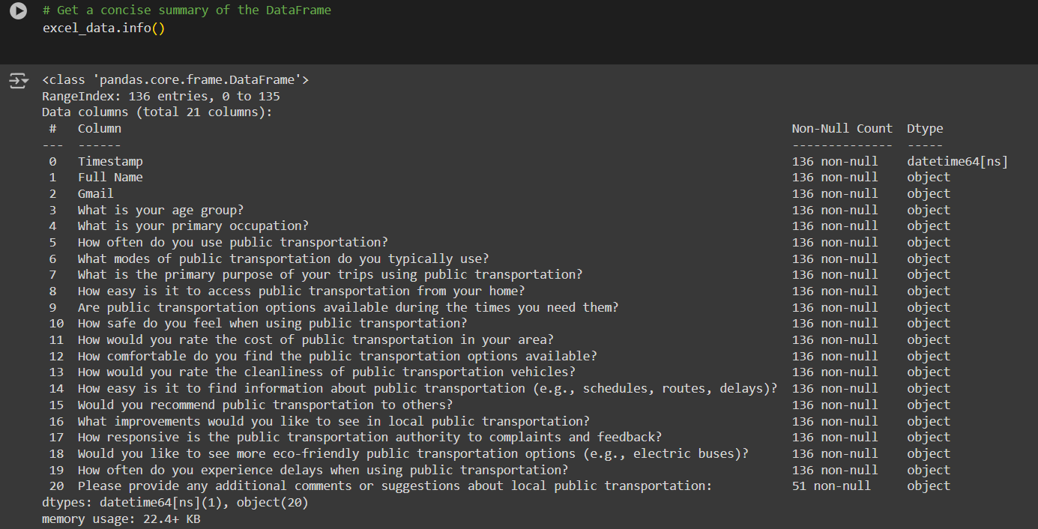



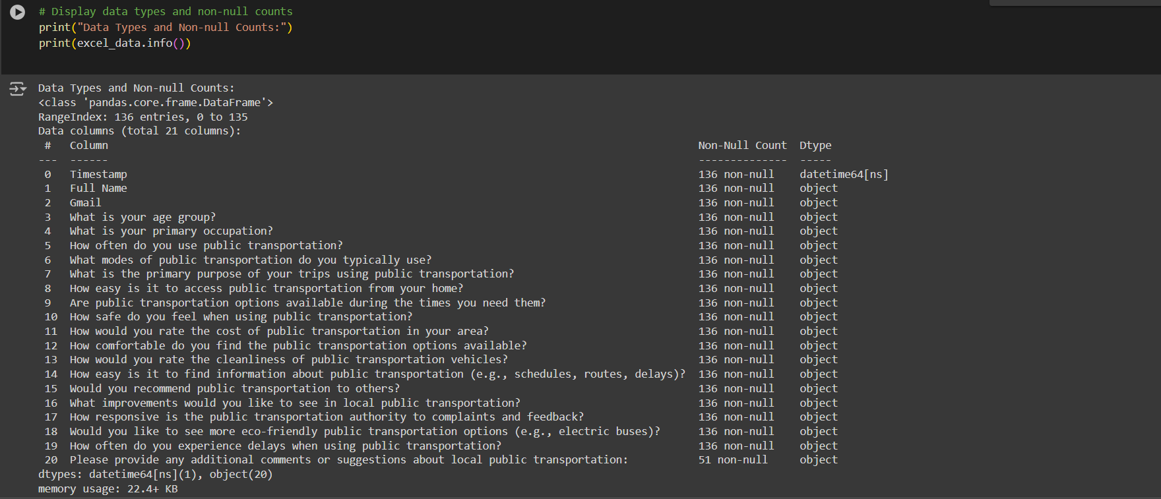

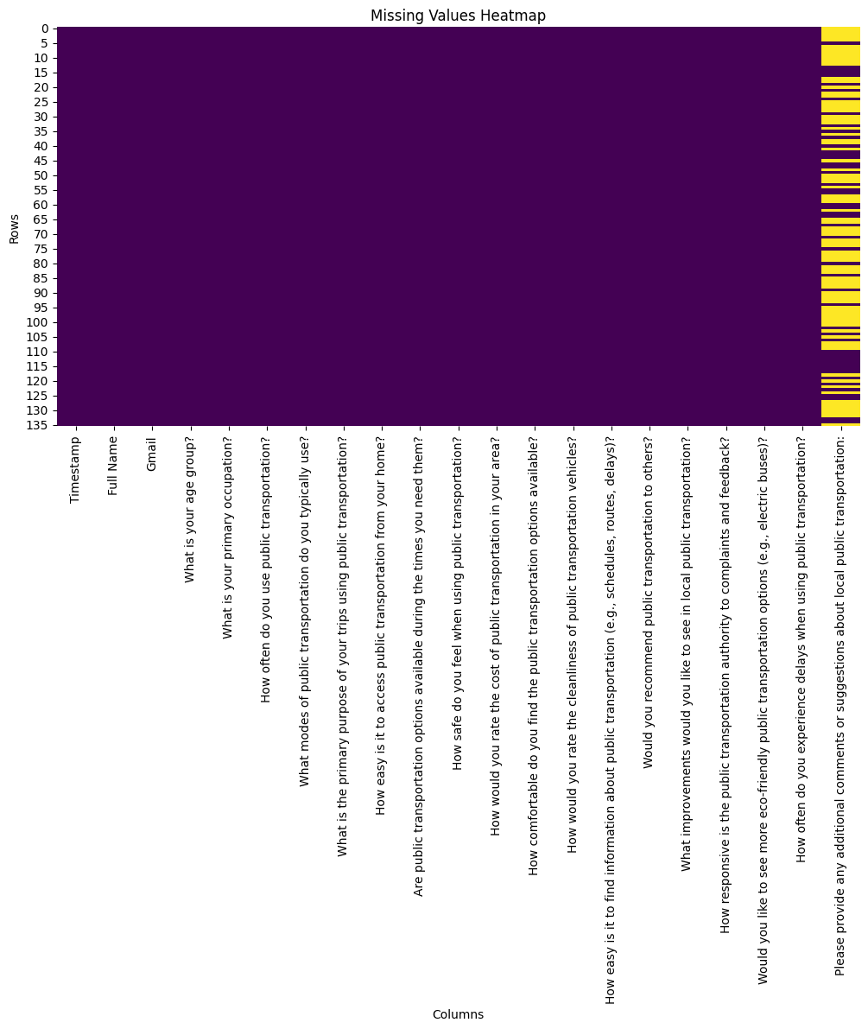

1. **Descriptive Statistics:** Include frequency counts and percentages for categorical variables.



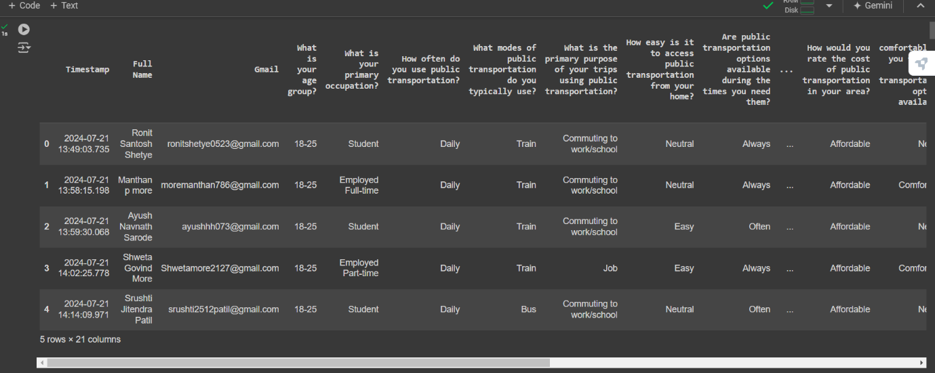





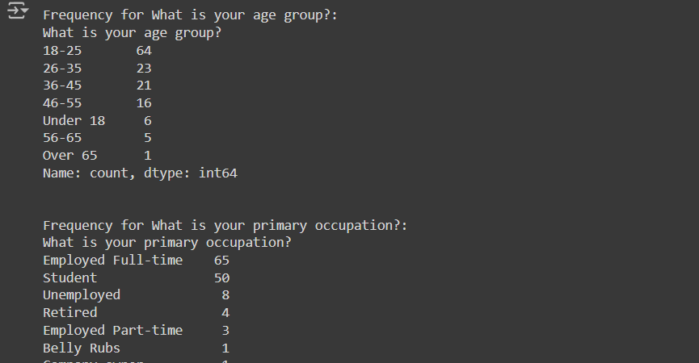





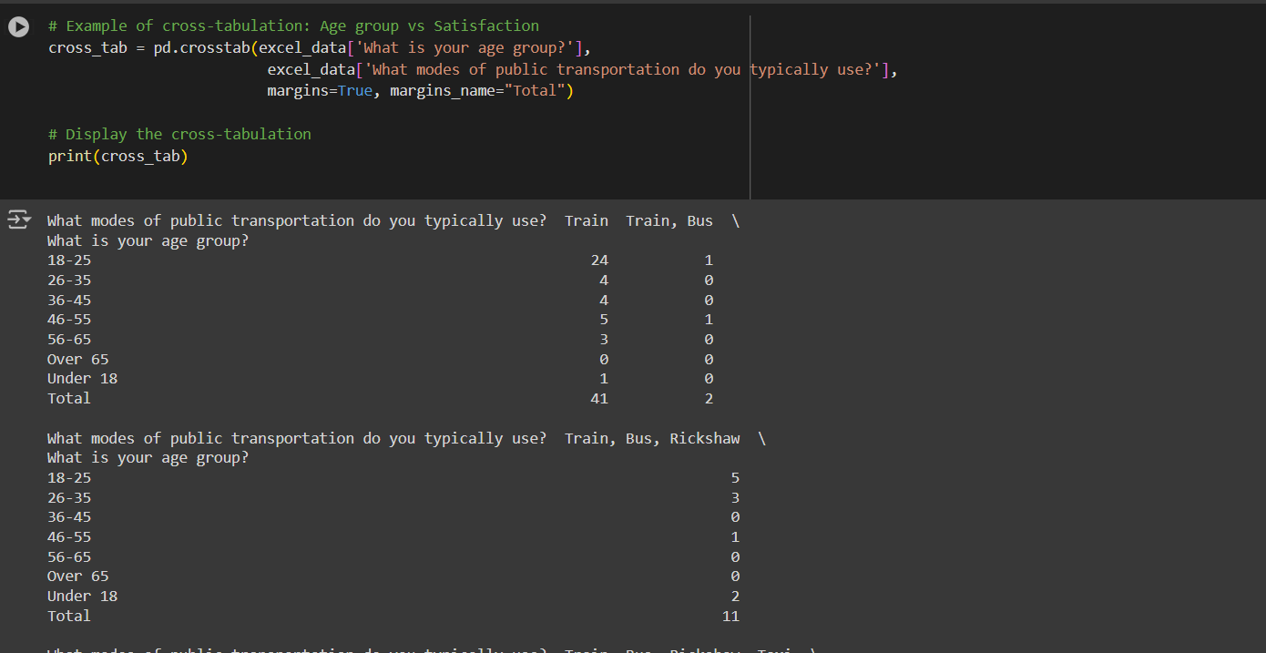



1. **Data Visualization:** Present various visualizations that highlight key trends and patterns in the data.

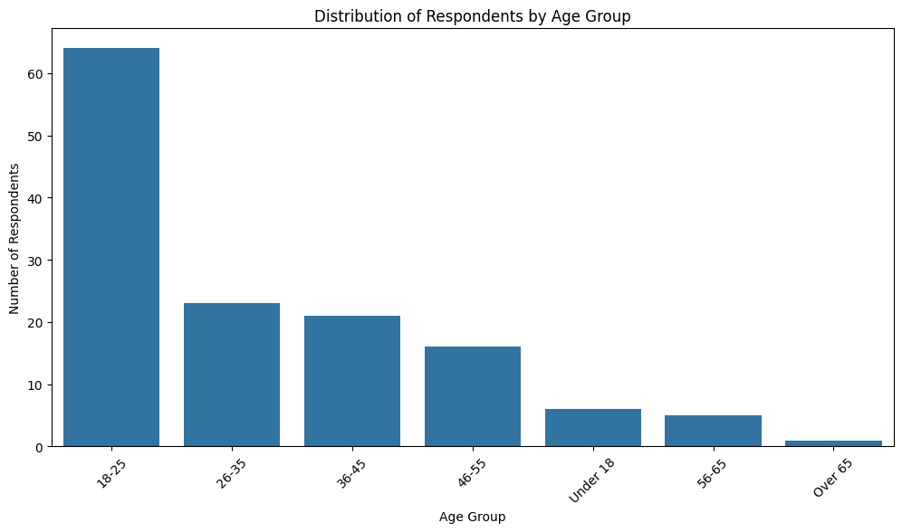

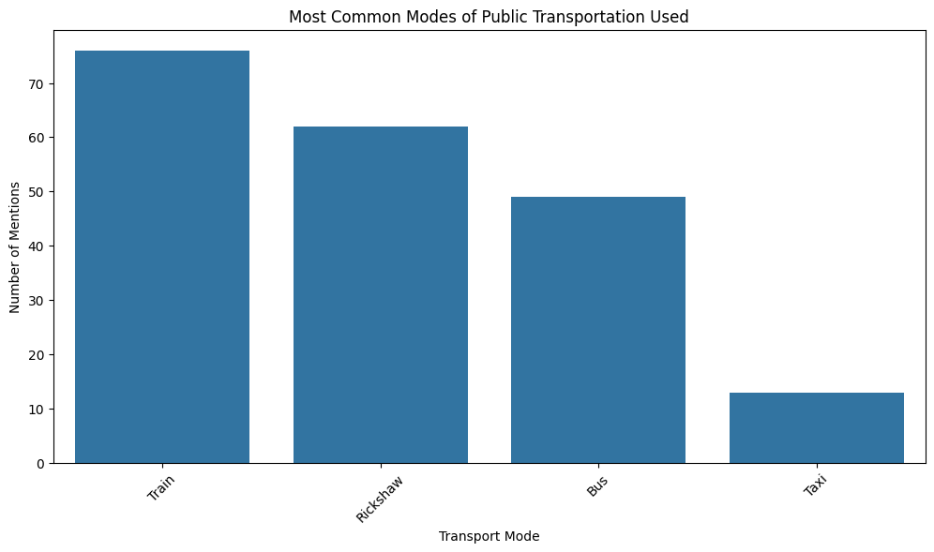

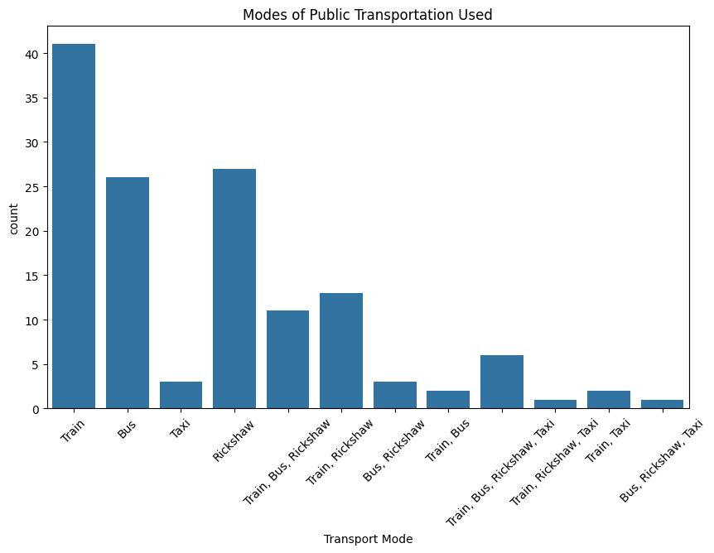

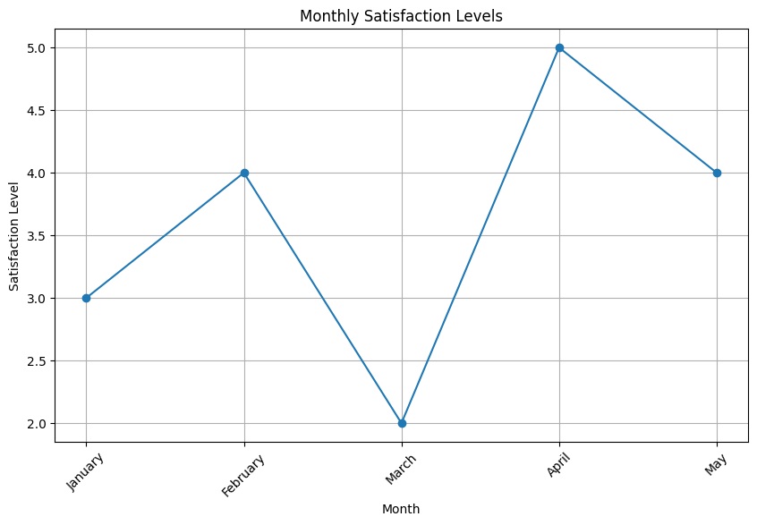

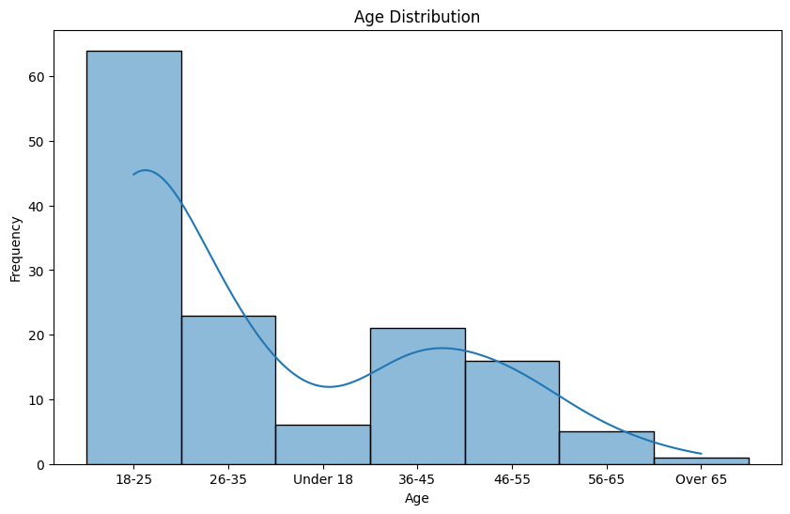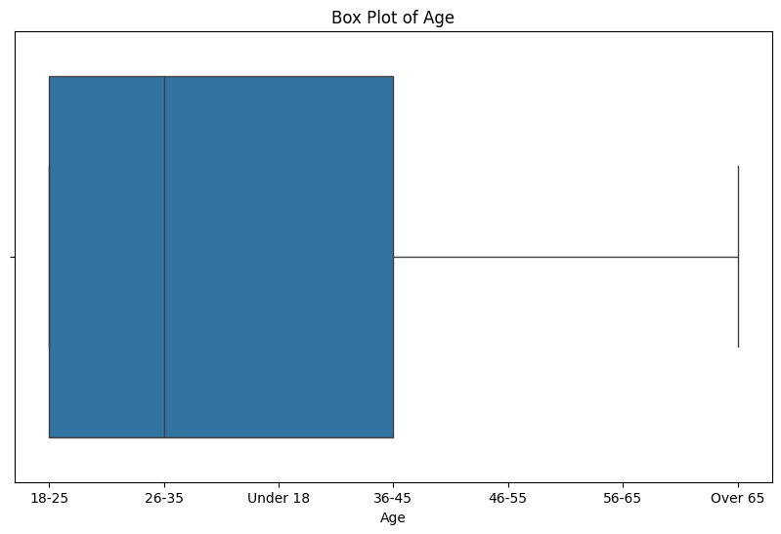

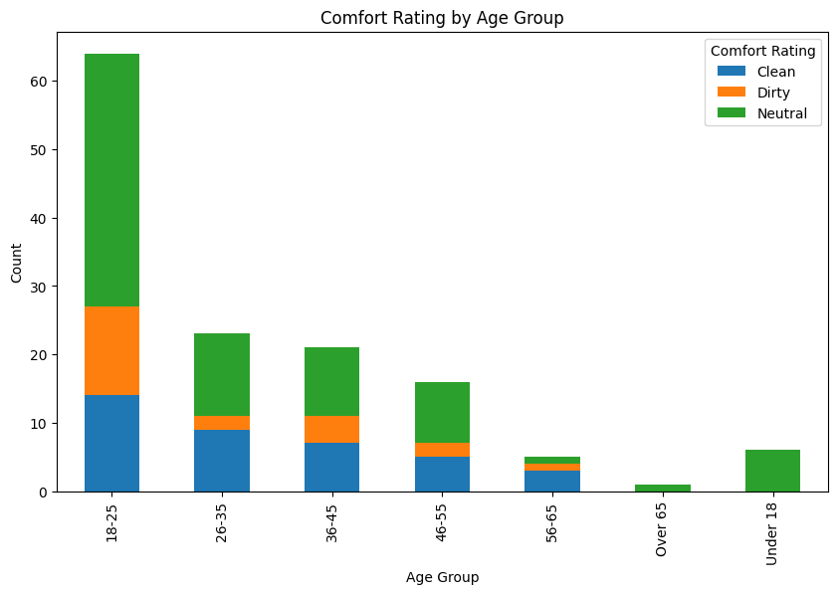

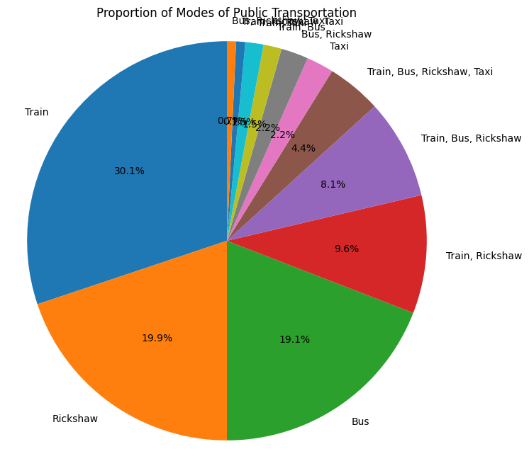

1. **Inferential Statistics:** ANOVA & Chi-square tests

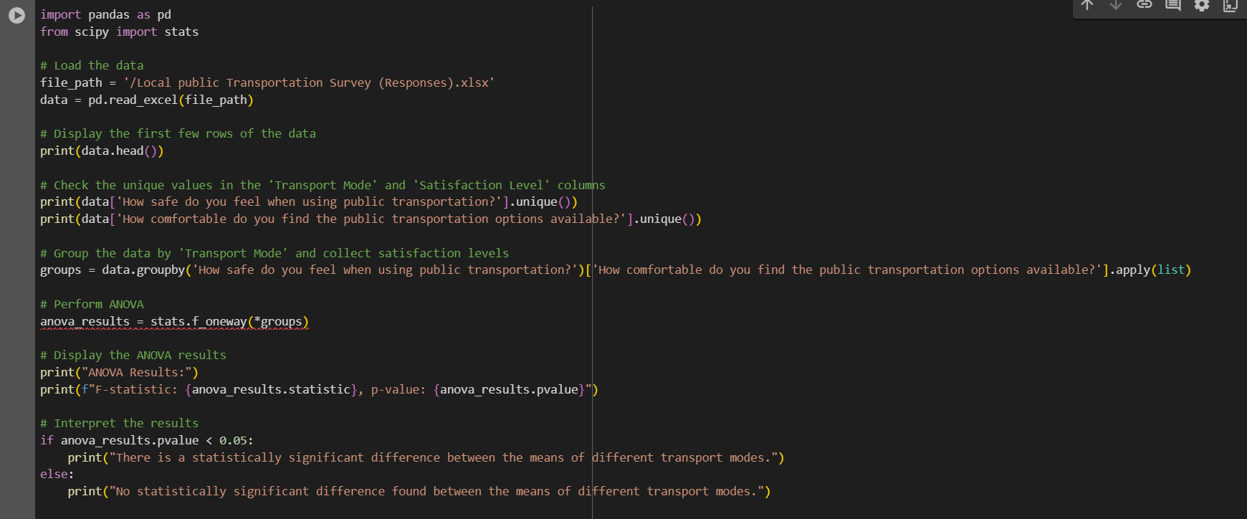

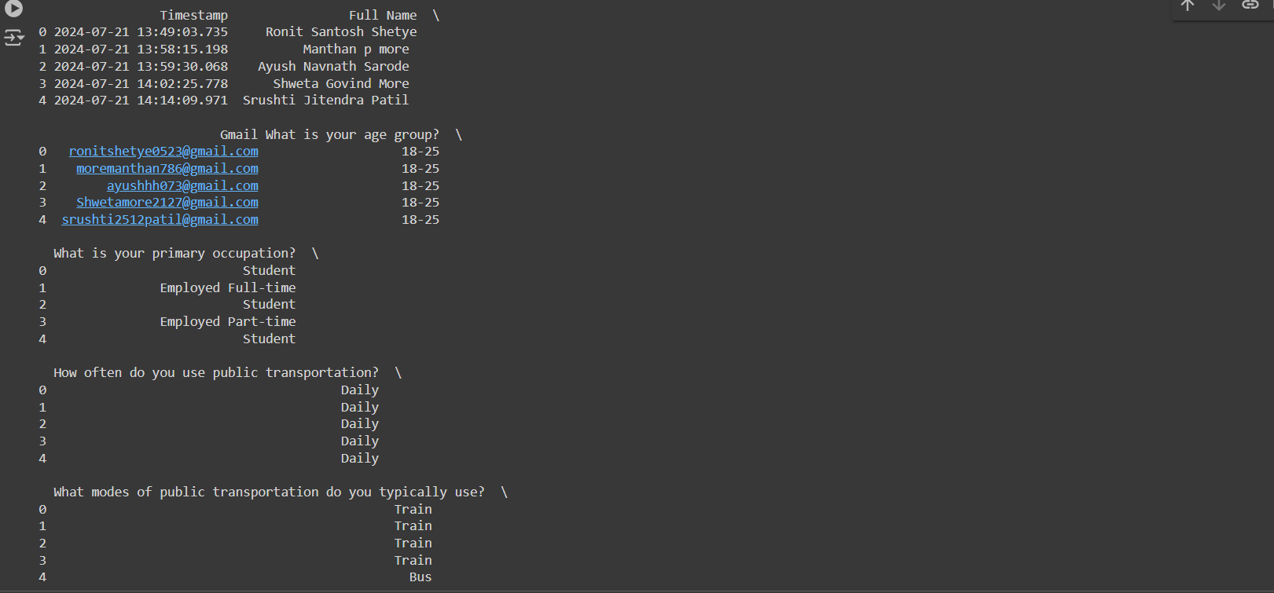



1. **Key Insights and Findings:**





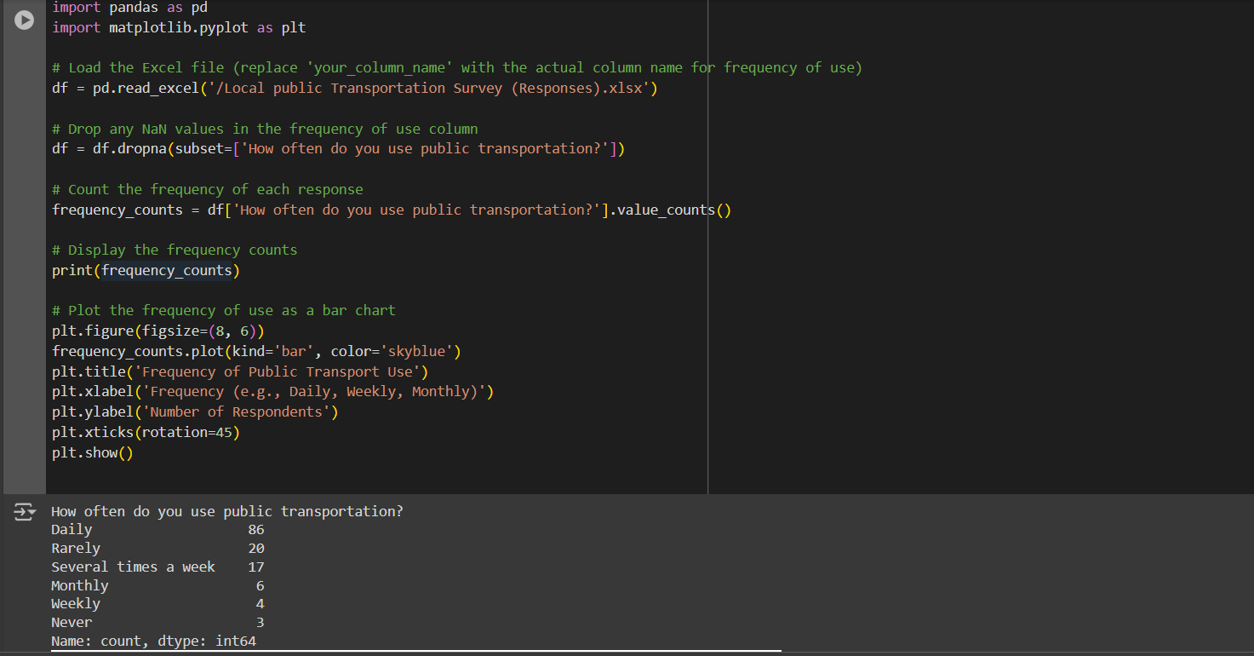

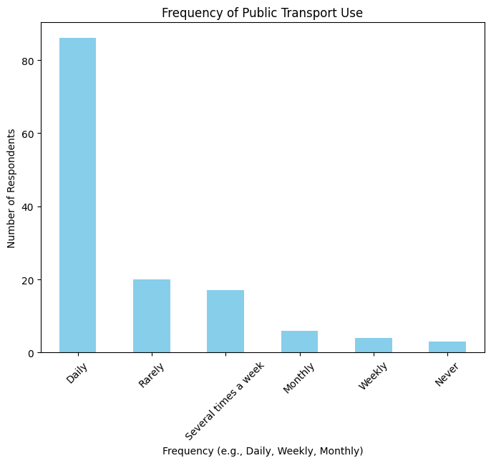

**CHAPTER 5: RESULT AND CONCLUSION**

In this chapter, we synthesize the key findings from the data analysis and provide an overview of the conclusions drawn from the research. The results section presents the insights derived from the survey data, while the conclusions provide a summary of the study’s implications, limitations, and potential future directions.

**Results**

The survey conducted on local public transportation provided several important insights into accessibility, convenience, and user satisfaction. The following are the key findings:

1. Accessibility:

The data analysis showed that a significant portion of respondents found the transportation system moderately accessible, especially in urban areas. However, there were challenges for individuals with disabilities or those in more remote areas where public transport routes were less frequent or nonexistent. Respondents rated the proximity to transit stops as satisfactory, but **accessibility for people with disabilities** received lower scores, indicating that improvements in infrastructure are needed.

1. Convenience:

The majority of users rated the convenience of public transport highly in terms of ease of use, especially with the introduction of contactless payment options and real-time information systems. However, service frequency in suburban areas received lower ratings, with many users reporting long wait times during peak hours. Travel time and the number of transfers were also key concerns, with users preferring more direct routes.

1. Satisfaction and Usage Frequency:

The analysis revealed a correlation between high satisfaction levels and frequency of use. Frequent users were more likely to be satisfied with public transport, while occasional users expressed dissatisfaction with aspects such as comfort, crowding, and service reliability. Gender-wise analysis highlighted that women reported more concerns about safety and comfort, particularly during off-peak hours, while men focused more on travel time and cost efficiency.

1. Common Complaints:

The most frequent complaints involved service delays, overcrowding, and poor infrastructure at bus stops and train stations. A smaller but notable proportion of respondents cited lack of cleanliness and limited seating availability.

**Conclusions**

Based on the survey data and analysis, the following conclusions can be drawn:

1. Accessibility Gaps: While the majority of users have access to public transportation within reasonable proximity, there are significant gaps in accessibility for people with disabilities and those living in suburban and rural areas. Addressing these gaps by improving infrastructure and expanding service coverage is crucial for increasing ridership.

2. Service Reliability and Convenience: Convenience plays a major role in influencing public transportation usage. Improving service frequency, especially during peak hours, and reducing wait times can significantly enhance user satisfaction. The introduction of technology, such as real-time tracking and contactless ticketing, has been positively received and should be expanded.

3. Gender-Specific Concerns: The data shows a clear difference in public transport experience across genders. Safety concerns for women should be a priority in future public transport improvements, along with enhancing comfort measures to accommodate more users.

4. Key Areas for Improvement: The study highlights the need for investment in service quality, particularly in terms of reliability, infrastructure maintenance, and cleanliness. These factors are critical to sustaining high user satisfaction and promoting greater public transport use.

5. Sustainability and Long-Term Impact: Improving public transport accessibility and convenience not only benefits users directly but also contribute to the sustainability of cities. By making public transport more reliable, efficient, and inclusive, cities can reduce their dependence on private vehicles, thus contributing to environmental goals.

**Recommendations for Future Research**

1. Targeted Interventions: Future research could focus on specific user groups, such as people with disabilities, elderly passengers, or women, to better understand their unique needs and how public transport can be improved for them.
2. Longitudinal Studies: Conducting a longitudinal survey over several years would help track changes in public transportation satisfaction over time and measure the effectiveness of improvements.
3. Integration with Other Modes: Further research should explore how public transport can be better integrated with **other forms of mobility, such as cycling or ride-sharing, to create a more seamless and efficient transportation network.

This chapter synthesizes the survey’s key findings, offering actionable insights for public transport authorities. The study highlights the need for targeted improvements in accessibility, convenience, and service reliability, while acknowledging the demographic differences in public transport experiences. These insights can be used to develop a more inclusive, user-friendly public transport system.

**CHAPTER 6: REFERENCES**

* <https://scholar.google.com/>
* <https://www.researchgate.net/>
* <https://www.jstor.org/>
* <https://pubmed.ncbi.nlm.nih.gov/>
* <https://www.mdpi.com/>
* <https://www.sciencedirect.com/>
* <https://www.ssrn.com/>
* <https://www.tandfonline.com/>
* <https://onlinelibrary.wiley.com/>
* <https://ieeexplore.ieee.org/>
* <https://www.doaj.org/>
* <https://www.worldtransitresearch.info/research/3462/>
* <https://pdfs.semanticscholar.org/f40f/3457bce5970bf6d597e6ec71555abec2099c.pdf>
* <https://www.openaire.eu/>
* <https://www.semanticscholar.org/>
* <https://www.academia.edu/>
* <https://www.lens.org/>
* <https://www.plos.org/>
* <https://www.biorxiv.org/>
* <https://www.medrxiv.org/>
* <https://www.ssoar.info/>
* <https://zenodo.org/>
* <https://www.econstor.eu/>
* <https://www.hathitrust.org/>

**CHAPTER 7: APPENDICES**

**QUESTIONNAIRE**

1) Name

2) Gmail

3)What is your age group?

* Under 18
* 18-25
* 26-35
* 36-45
* 46-55
* 56-65
* Over 65

4)What is your primary occupation?

* Student
* Employed full-time
* Employed part-time
* Unemployed
* Retired
* Other

5) How often do you use public transportation?

* Daily
* Several times a week
* Weekly
* Monthly
* Rarely
* Never

6) What modes of public transportation do you typically use?

* Train
* Bus
* Rickshaw
* Taxi

7)What is the primary purpose of your trips using public transportation?

* Commuting to work/school
* Shopping
* Medical appliances
* Other

8)How easy is it to access public transportation from your home?

* Easy
* Neutral
* Difficult

9) Are public transportation options available during the times you need them?

* Always
* Often
* Sometimes
* Never

10) How safe do you feel when using public transportation?

* Safe
* Neutral
* Unsafe

11) How would you rate the cost of public transportation in your area?

* Affordable
* Neutral
* Expensive

12) How comfortable do you find the public transportation options available?

* Comfortable
* Neutral
* Uncomfortable

13) How would you rate the cleanliness of public transportation vehicles?

* Clean
* Neutral
* Dirty

14) How easy is it to find information about public transportation (e.g., schedules, routes, delays)?

* Easy
* Neutral
* Difficult

15) Would you recommend public transportation to others?

* Yes
* Maybe
* No

16) What improvements would you like to see in local public transportation?

* Increased frequency of services
* Expanded routes
* Lower rates
* Improved safety measure
* Better cleanliness
* Other

17) How responsive is the public transportation authority to complaints and feedbacks?

* Very responsible
* Neutral
* Unresponsive

18) Would you like to see more eco-friendly transportation?

* Yes
* Maybe
* No

19) How often do you experience delays while using public transportation?

* Always
* Often
* Sometimes
* Rarely
* Never

20) Please provide any additional comments or suggestions about public transportation.